MOXIE

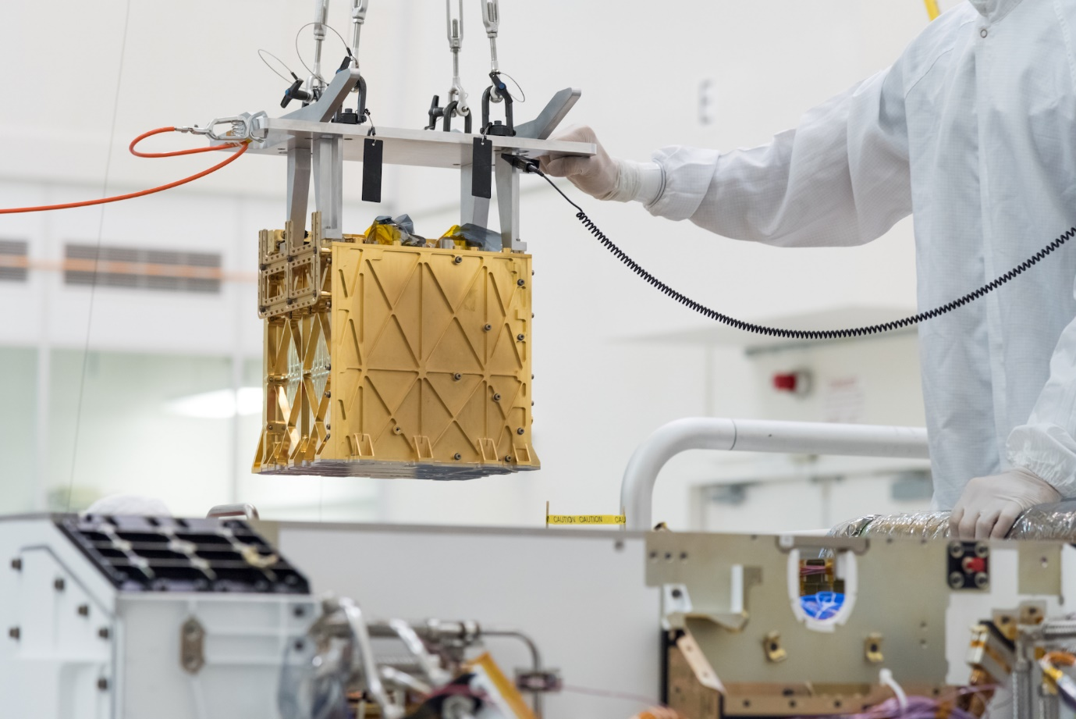

The Mars Oxygen In-Situ Resource Utilization Experiment (**MOXIE**) is an instrument on the **Perseverance Rover**. It makes **oxygen (O2)** out of **carbon dioxide (CO2) gas** in the Martian atmosphere.

This is useful because Mars has very little oxygen in its atmosphere, unlike Earth. **Humans will need oxygen to visit Mars.**

MOXIE works the same way trees do on Earth – it “breathes in” carbon dioxide and “breathes out” oxygen. It takes one oxygen atom from each CO2 molecule, and then combines two oxygen atoms to make O2.

MOXIE is only a technology demonstration, so it does not produce much oxygen. In one hour, it can make up to 10 grams of oxygen; this is enough for about 20 minutes of air.

As well as making breathable air for astronauts, oxygen has other uses. **Liquid oxygen can power rockets**, which will be very important for future human missions to Mars.

You can learn more about MOXIE here: <https://mars.nasa.gov/mars2020/spacecraft/instruments/moxie/>

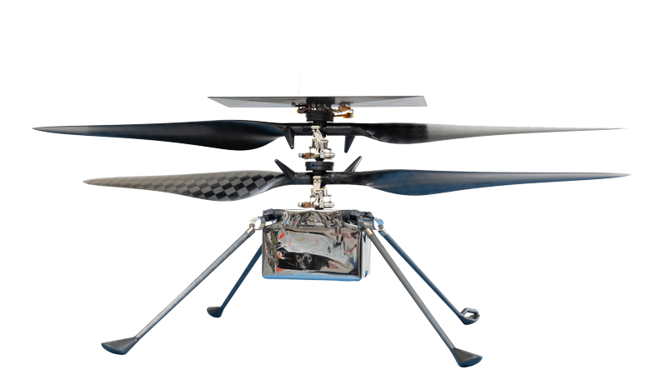INGENUITY

The **Ingenuity helicopter** is a **self-piloting drone** that came to Mars with the **Perseverance rover**. Its lightweight construction and long blades allow it to fly in the **thin Martian atmosphere**.

Ingenuity is the first time scientists have ever attempted **powered flight on another world**. Because **helicopters use air resistance** to push themselves into the air, **flying is much more difficult on a place like Mars**, which only has about **1 per cent of the atmosphere of Earth**.

Between April 2021 and June 2022, Ingenuity conducted **29 flights on the Martian surface**. Its longest flight travelled 704 metres.

After proving flight was possible on Mars, Ingenuity has been **helping Perseverance see the road ahead**. This helps operations staff **pick the safest routes** for the rover, **avoiding obstacles and hazards**.

**In the future**, helicopters could **help astronauts survey regions** they can’t reach by walking or rover, and **scout out good locations** for exploration or setting up base camp.

You can learn more about Ingenuity here:   
<https://mars.nasa.gov/technology/helicopter/>

MARS SAMPLE RETURN

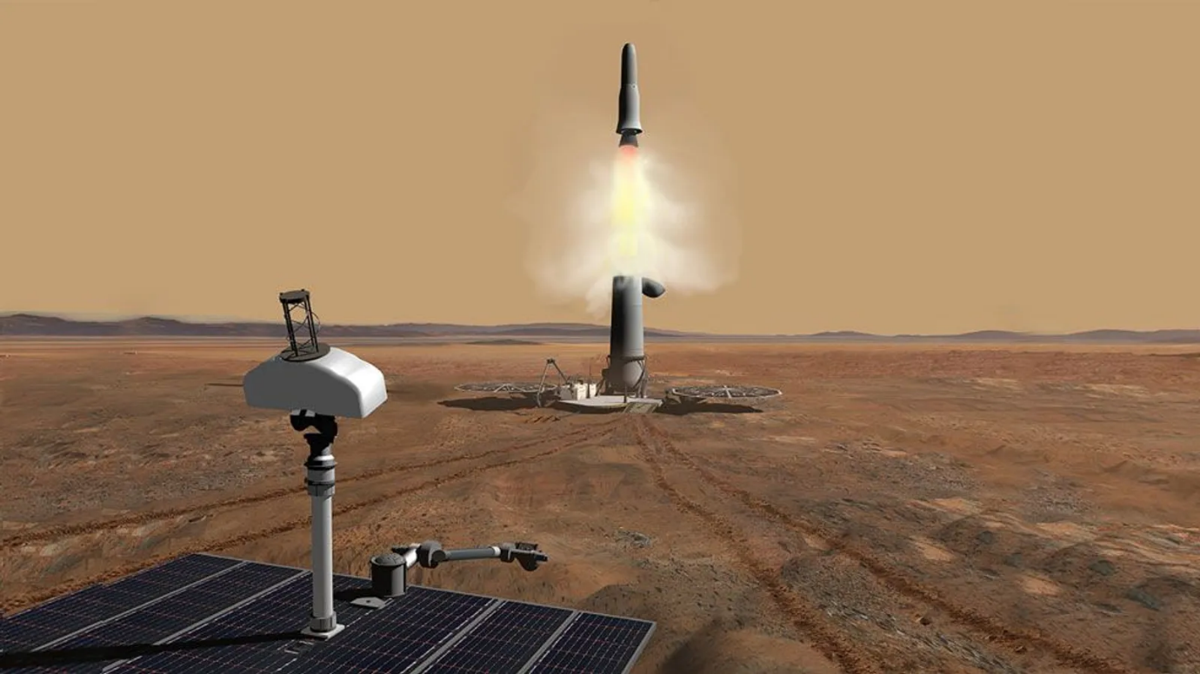

Mars Sample Return is a **multi-mission project** to **collect samples from the Martian surface** and **return them to Earth** for analysis.

While scientists have **already returned moon and asteroid samples**, this will be the first time we’ve ever brought samples home from another **planet**.

Rovers are limited by weight in what tools they can bring with them. Getting undisturbed samples back to Earth means scientists can use all of the instruments and laboratories here to examine the samples for signs of past life. As technology evolves, scientists can use new Earth tools to learn more about Mars.

The first stage of Mars Sample Return happens with the **Perseverance rover**. It is now in the process of **collecting Martian rock samples**, sealing and **storing them in sample tubes**.

It will hold onto the tubes and eventually drop them on the ground, to be collected by **a future mission**. That mission is still in development by NASA and the European Space Agency. It will involve a new rover collecting the samples and placing them into a rocket, which shoots them into orbit. Another spacecraft collects the samples and sends them back to Earth.

You can learn more about Mars Sample Return here:   
<https://mars.nasa.gov/msr/>

LANDING ON MARS

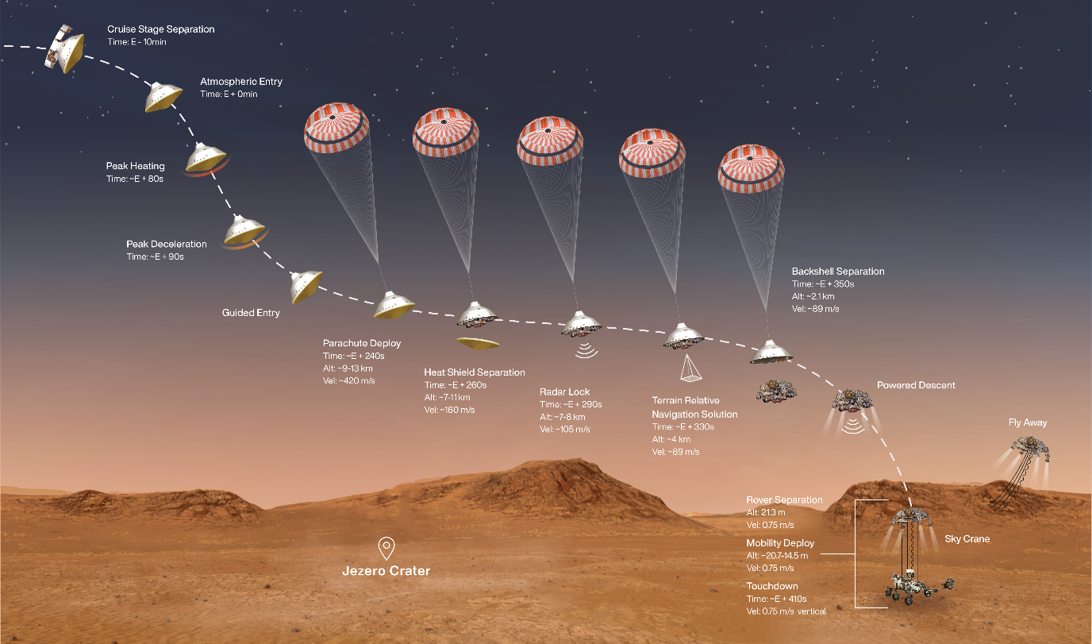

**Landing a spacecraft on another world is hard**—and this is especially true on Mars. Even though the gravity and atmosphere on Mars are much less than on Earth, spacecraft still reach extreme speeds and temperatures as they hurtle towards the surface.

**Only about 40 per cent of missions sent to Mars have been successful.** Many things can go wrong during this mission phase, which is also known as **Entry, Descent and Landing (EDL)**. On Mars, it is sometimes described as “seven minutes of terror” because this is when one error could kill the mission before it even properly begins.

The main goal of EDL is to slow the spacecraft down enough that it can land gently on the surface. To achieve this, NASA equipped Perseverance with **a supersonic parachute**, deployed about 10 kilometres above the surface to reduce its speed significantly.

Next comes the **descent stage**. This acts like a jet pack; firing rockets pointed towards the ground to slow it down even further. At the end of this manoeuvre, the descent stage lowers Perseverance on a **sky crane**, a set of cables a bit over 6 metres long. The cables are cut as soon as the rover’s wheels touch the ground, and the descent stage flies away to crash in the distance.

You can learn more about Perseverance’s Entry, Descent and Landing here: <https://mars.nasa.gov/mars2020/timeline/landing/entry-descent-landing/>   
DRIVING ON MARS

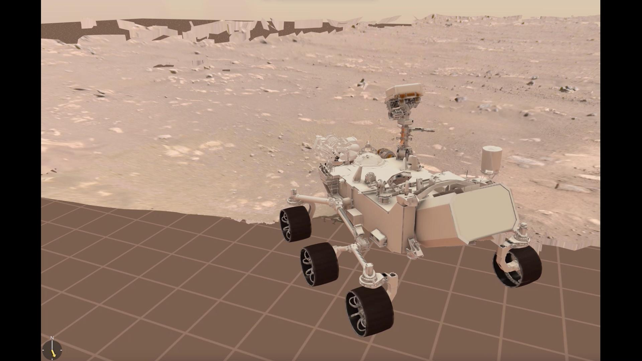

Mars is so far away that **communication with Perseverance takes a long time**.

It can take 5 to 20 minutes for a signal to travel from one planet to the other, so Perseverance is built to do many things independently, without user input. This includes some of its driving.

Rover drivers on Earth plan Perseverance’s next destination by viewing its surroundings on a computer screen. They wear special 3D glasses to see the environment around the rover better.

Once they’ve decided where Perseverance will go, that data is sent to the rover’s **auto-navigation system**, AutoNav.

AutoNav creates 3D maps of the terrain ahead, looks out for any hazards, and chooses a route that moves around any obstacles that might be present. Humans on Earth are not required to oversee any of these tasks: it is all handled by the computer.

You can learn more about how Perseverance drives here: <https://mars.nasa.gov/resources/26660/how-perseverance-drives-on-mars/>